**Data Analysis Excel**

Setting up the Application.

Set the setting of the Data Analysis by going to the Data Analysis in the Ribbon of the Excel 2007. As showed in the Diagram below.



Set the **Criteria Directory** which must be pointing to the Directory where the Criteria Setting files are located.

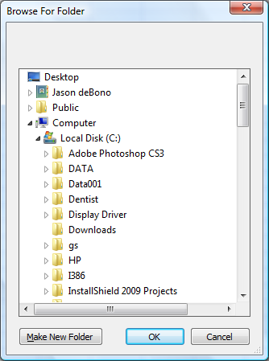

Set the **Connection** to the SQL Server.

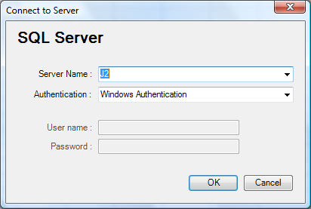 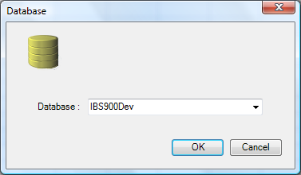

Set the **Database** to the Database you are going to run the Reports

Creating a New Setting File

The Document Action is controlled by an xml file. The setting of the Criteria above can be seen in the Full example below.

<?xml version="1.0" encoding="utf-8" ?>

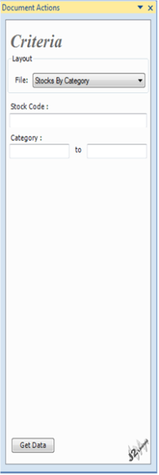<IBSAnalysis>

<CriteriaGroup>

<Object Type="CriteriaLike" Name="StkCode">

<DisplayName>Stock Code :</DisplayName>

<SQLFieldName>StkCode</SQLFieldName>

<Text></Text>

</Object>

<Object Type="CriteriaBetween" Name="Categ">

<DisplayName>Category :</DisplayName>

<SQLFieldName>StkCateg</SQLFieldName>

<TextFrom></TextFrom>

<TextTo></TextTo>

</Object>

</CriteriaGroup>

<SQLCMD>

Select StkCode, StkDesc, StkPhysQty

From Stocks

Where StkStatus = 1

%%StkCode%%

%%Categ%%

</SQLCMD>

</IBSAnalysis>

There are two main Parts in the Criteria Setting files. The **CriteriaGroup** and the **SQLCMD**.

CriteriaGroup

Each Criteria Object can be of Type “**CriteriaBetween**”, “**CriteriaLike**” and “**CriteriaEquals**”. The CriteriaBetween and CriteriaLike Support “ValueType” this can be “Text”, “Date” or “NumericUpDown”. “Text” is Default in all cases. NumericUpDown supports “Minimum” and “Maximum” values.

Examples:

e.g. for a DataRange Criteria

<Object Type="CriteriaBetween" Name="DateRange" ValueType="Date">

<DisplayName>Date :</DisplayName>

<SQLFieldName>TranHead.THDate</SQLFieldName>

<TextFrom></TextFrom>

<TextTo></TextTo>

</Object>

To apply this is a where statement use %%**Object Name**%% in this example use %%DateRange%%

e.g. of a Numeric Up Down

<Object Type="CriteriaEquals" Name="DateLeadingFrom" ValueType="NumericUpDown">

<DisplayName>Leading Days :</DisplayName>

<Minimum>-356</Minimum>

<Maximum>356</Maximum>

<Text>-7</Text>

</Object>

Since the SQLFieldName is not set this can only be use as a substitution. In case of a CriteriaBetween refer to the different Textbox with %%Name**TEXTFROM**%% and %%Name**TEXTTO**%%